Active Response Training
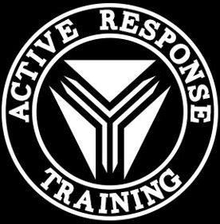

“The Unthinkable- Tactics and Concepts for the Gravest Extreme”
Class Registration Form

Name________________________________________________________________________________

Address______________________________________________________________________________

Phone #______________________________________________________________________________

Email________________________________________________________________________________

Please complete this form and enclose it with a check or money order for $350 payable to “Greg Ellifritz”
Send completed registration form and class fees to:
Greg Ellifritz
6220 Emberwood Rd
Dublin, OH 43017

Class fees must be paid in full and are non-refundable. Registration limited to the first 20 paid students.

